Code

* Download Rmd

#### [Visualization of DLQI Mixed Models Results](https://github.com/VIS-SIG/Wonderful-Wednesdays/tree/master/data/2021/2021-01-13) by Agustin Calatroni

Figure

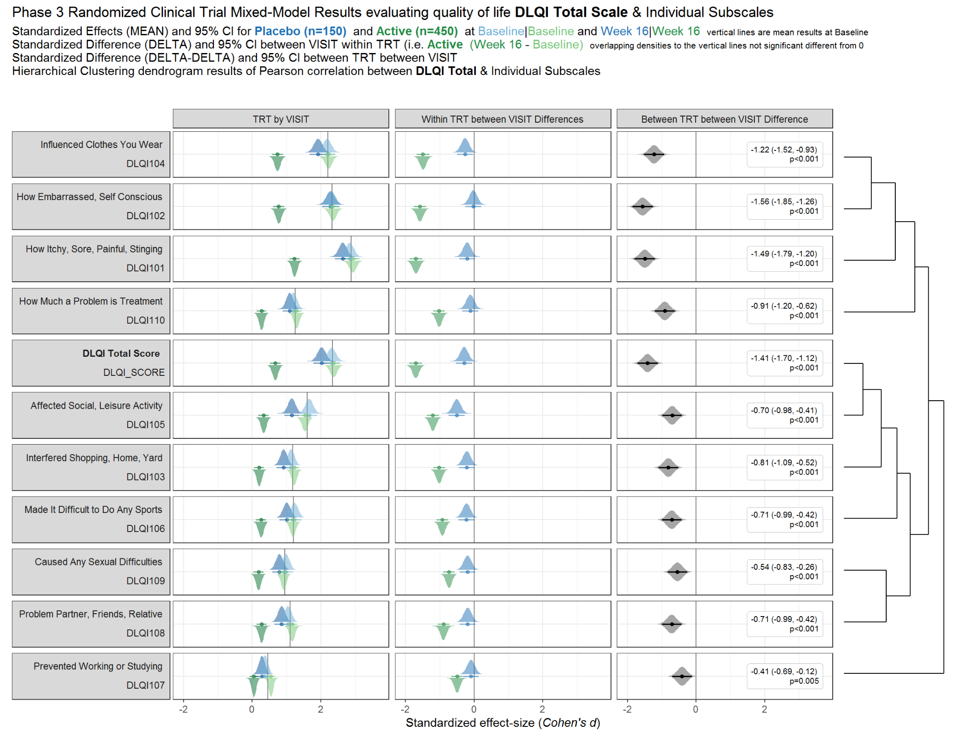

Table

|  |  |  |  |  |  |  |  |
| --- | --- | --- | --- | --- | --- | --- | --- |
| Phase 3 Randomized Clinical Trial Mixed-Model Results evaluating quality of life DLQI Total Scale & Individual Subscales | | | | | | | |
| Standardized Effects (95% CI) and Standardized Differences (95% CI) and p-values | | | | | | | |
| LAB | Placebo | | Active | | Within TRT between VISIT | | Overall |
| Baseline | Week 16 | Baseline | Week 16 | Placebo | Active | Difference |
| Influenced Clothes You Wear  DLQI104 | 2.19 (1.94, 2.43) | 1.92 (1.68, 2.16) | 2.23 (2.03, 2.42) | 0.74 (0.57, 0.90) | −0.26 (−0.50, −0.03)  p=0.025 | −1.49 (−1.67, −1.31)  p<0.001 | −1.22 (−1.52, −0.93)  p<0.001 |
| How Embarrassed, Self Conscious  DLQI102 | 2.31 (2.06, 2.55) | 2.28 (2.03, 2.53) | 2.36 (2.16, 2.55) | 0.77 (0.62, 0.93) | −0.03 (−0.26, 0.21)  p=0.83 | −1.58 (−1.76, −1.40)  p<0.001 | −1.56 (−1.85, −1.26)  p<0.001 |
| How Itchy, Sore, Painful, Stinging  DLQI101 | 2.84 (2.61, 3.08) | 2.64 (2.41, 2.88) | 2.93 (2.73, 3.13) | 1.23 (1.09, 1.38) | −0.20 (−0.43, 0.03)  p=0.084 | −1.70 (−1.88, −1.51)  p<0.001 | −1.49 (−1.79, −1.20)  p<0.001 |
| How Much a Problem is Treatment  DLQI110 | 1.21 (1.00, 1.41) | 1.09 (0.89, 1.30) | 1.29 (1.14, 1.44) | 0.27 (0.13, 0.41) | −0.11 (−0.34, 0.12)  p=0.35 | −1.02 (−1.19, −0.85)  p<0.001 | −0.91 (−1.20, −0.62)  p<0.001 |
| DLQI Total Score  DLQI_SCORE | 2.32 (2.07, 2.56) | 2.02 (1.78, 2.27) | 2.37 (2.18, 2.57) | 0.67 (0.51, 0.83) | −0.29 (−0.52, −0.06)  p=0.014 | −1.70 (−1.89, −1.52)  p<0.001 | −1.41 (−1.70, −1.12)  p<0.001 |
| Affected Social, Leisure Activity  DLQI105 | 1.66 (1.44, 1.89) | 1.15 (0.93, 1.37) | 1.54 (1.37, 1.70) | 0.33 (0.18, 0.48) | −0.51 (−0.74, −0.28)  p<0.001 | −1.20 (−1.38, −1.03)  p<0.001 | −0.70 (−0.98, −0.41)  p<0.001 |
| Interfered Shopping, Home, Yard  DLQI103 | 1.13 (0.93, 1.34) | 0.92 (0.71, 1.12) | 1.22 (1.07, 1.38) | 0.20 (0.06, 0.35) | −0.21 (−0.44, 0.02)  p=0.071 | −1.02 (−1.19, −0.85)  p<0.001 | −0.81 (−1.09, −0.52)  p<0.001 |
| Made It Difficult to Do Any Sports  DLQI106 | 1.23 (1.01, 1.45) | 1.01 (0.79, 1.23) | 1.19 (1.03, 1.35) | 0.26 (0.11, 0.41) | −0.22 (−0.45, 0.01)  p=0.060 | −0.93 (−1.10, −0.76)  p<0.001 | −0.71 (−0.99, −0.42)  p<0.001 |
| Caused Any Sexual Difficulties  DLQI109 | 0.99 (0.78, 1.19) | 0.79 (0.58, 1.00) | 0.92 (0.77, 1.07) | 0.18 (0.04, 0.33) | −0.19 (−0.42, 0.04)  p=0.10 | −0.73 (−0.90, −0.56)  p<0.001 | −0.54 (−0.83, −0.26)  p<0.001 |
| Problem Partner, Friends, Relative  DLQI108 | 1.05 (0.84, 1.25) | 0.86 (0.65, 1.07) | 1.17 (1.01, 1.32) | 0.27 (0.13, 0.41) | −0.19 (−0.42, 0.04)  p=0.11 | −0.90 (−1.07, −0.73)  p<0.001 | −0.71 (−0.99, −0.42)  p<0.001 |
| Prevented Working or Studying  DLQI107 | 0.37 (0.20, 0.55) | 0.28 (0.10, 0.46) | 0.54 (0.42, 0.67) | 0.05 (−0.08, 0.18) | −0.09 (−0.32, 0.14)  p=0.44 | −0.50 (−0.66, −0.33)  p<0.001 | −0.41 (−0.69, −0.12)  p=0.005 |

Table (Raw)

|  |  |  |  |  |  |  |  |
| --- | --- | --- | --- | --- | --- | --- | --- |
| Phase 3 Randomized Clinical Trial Mixed-Model Results evaluating quality of life DLQI Total Scale & Individual Subscales | | | | | | | |
| Effects (95% CI) and Differences (95% CI) and p-values | | | | | | | |
| LAB | Placebo | | Active | | Within TRT between VISIT | | Overall |
| Baseline | Week 16 | Baseline | Week 16 | Placebo | Active | Difference |
| Influenced Clothes You Wear  DLQI104 | 1.63 (1.47, 1.79) | 1.44 (1.27, 1.60) | 1.66 (1.55, 1.78) | 0.55 (0.43, 0.67) | −0.20 (−0.37, −0.03)  p=0.025 | −1.11 (−1.24, −0.99)  p<0.001 | −0.92 (−1.13, −0.70)  p<0.001 |
| How Embarrassed, Self Conscious  DLQI102 | 1.61 (1.46, 1.76) | 1.60 (1.44, 1.75) | 1.65 (1.54, 1.75) | 0.54 (0.43, 0.65) | −0.02 (−0.18, 0.14)  p=0.83 | −1.10 (−1.22, −0.99)  p<0.001 | −1.09 (−1.29, −0.89)  p<0.001 |
| How Itchy, Sore, Painful, Stinging  DLQI101 | 1.97 (1.85, 2.10) | 1.83 (1.70, 1.96) | 2.03 (1.94, 2.12) | 0.86 (0.76, 0.95) | −0.14 (−0.30, 0.02)  p=0.083 | −1.18 (−1.29, −1.06)  p<0.001 | −1.04 (−1.23, −0.84)  p<0.001 |
| How Much a Problem is Treatment  DLQI110 | 0.88 (0.74, 1.02) | 0.80 (0.65, 0.94) | 0.94 (0.84, 1.04) | 0.20 (0.09, 0.30) | −0.08 (−0.25, 0.09)  p=0.35 | −0.75 (−0.87, −0.63)  p<0.001 | −0.67 (−0.87, −0.46)  p<0.001 |
| DLQI Total Score  DLQI_SCORE | 10.57 (9.60, 11.54) | 9.24 (8.25, 10.23) | 10.83 (10.14, 11.52) | 3.06 (2.36, 3.77) | −1.33 (−2.38, −0.28)  p=0.013 | −7.77 (−8.52, −7.02)  p<0.001 | −6.44 (−7.73, −5.15)  p<0.001 |
| Affected Social, Leisure Activity  DLQI105 | 1.11 (0.97, 1.24) | 0.77 (0.63, 0.91) | 1.02 (0.93, 1.12) | 0.22 (0.12, 0.32) | −0.34 (−0.49, −0.18)  p<0.001 | −0.80 (−0.91, −0.69)  p<0.001 | −0.46 (−0.65, −0.27)  p<0.001 |
| Interfered Shopping, Home, Yard  DLQI103 | 0.74 (0.61, 0.87) | 0.60 (0.47, 0.73) | 0.80 (0.71, 0.89) | 0.13 (0.04, 0.23) | −0.14 (−0.29, 0.01)  p=0.070 | −0.67 (−0.77, −0.56)  p<0.001 | −0.53 (−0.71, −0.34)  p<0.001 |
| Made It Difficult to Do Any Sports  DLQI106 | 0.82 (0.68, 0.96) | 0.67 (0.53, 0.81) | 0.79 (0.69, 0.89) | 0.17 (0.07, 0.27) | −0.15 (−0.30, 0.01)  p=0.059 | −0.62 (−0.73, −0.51)  p<0.001 | −0.47 (−0.66, −0.28)  p<0.001 |
| Caused Any Sexual Difficulties  DLQI109 | 0.61 (0.49, 0.74) | 0.49 (0.37, 0.62) | 0.57 (0.48, 0.66) | 0.11 (0.02, 0.21) | −0.12 (−0.26, 0.02)  p=0.10 | −0.46 (−0.56, −0.35)  p<0.001 | −0.34 (−0.51, −0.16)  p<0.001 |
| Problem Partner, Friends, Relative  DLQI108 | 0.64 (0.52, 0.76) | 0.53 (0.40, 0.65) | 0.71 (0.63, 0.80) | 0.17 (0.08, 0.25) | −0.11 (−0.26, 0.03)  p=0.11 | −0.55 (−0.65, −0.45)  p<0.001 | −0.43 (−0.61, −0.26)  p<0.001 |
| Prevented Working or Studying  DLQI107 | 0.26 (0.14, 0.38) | 0.20 (0.07, 0.32) | 0.38 (0.29, 0.47) | 0.03 (−0.06, 0.12) | −0.06 (−0.22, 0.10)  p=0.44 | −0.35 (−0.46, −0.23)  p<0.001 | −0.28 (−0.48, −0.09)  p=0.005 |

